* [Objectives](https://googlepluralsight.qwiklabs.com/focuses/23518018?parent=lti_session" \l "step2)
* [Task 1. Create a Cloud Monitoring workspace](https://googlepluralsight.qwiklabs.com/focuses/23518018?parent=lti_session#step3)
* [Task 2. Custom dashboards](https://googlepluralsight.qwiklabs.com/focuses/23518018?parent=lti_session#step4)
* [Task 3. Alerting policies](https://googlepluralsight.qwiklabs.com/focuses/23518018?parent=lti_session#step5)
* [Task 4. Resource groups](https://googlepluralsight.qwiklabs.com/focuses/23518018?parent=lti_session#step6)
* [Task 5. Uptime monitoring](https://googlepluralsight.qwiklabs.com/focuses/23518018?parent=lti_session#step7)
* [Task 6. Disable the alert](https://googlepluralsight.qwiklabs.com/focuses/23518018?parent=lti_session#step8)
* [Task 7. Review](https://googlepluralsight.qwiklabs.com/focuses/23518018?parent=lti_session#step9)
* [End your lab](https://googlepluralsight.qwiklabs.com/focuses/23518018?parent=lti_session#step10)

Resource Monitoring

**Overview**

In this lab, you learn how to use Cloud Monitoring to gain insight into applications that run on Google Cloud.

**Objectives**

* In this lab, you learn how to perform the following tasks:
* Explore Cloud Monitoring
* Add charts to dashboards
* Create alerts with multiple conditions
* Create resource groups
* Create uptime checks

**Monitoring workspace**

Verify resources to monitor

Three VM instances have been created for you that you will monitor.

In the Cloud Console, on the **Navigation menu** (Navigation menu icon), click **Compute Engine** > **VM instances**. Notice the **nginxstack-1**, **nginxstack-2** and **nginxstack-3** instances.

Create a Monitoring workspace

You will now setup a Monitoring workspace that's tied to your Qwiklabs GCP Project. The following steps create a new account that has a free trial of Monitoring.

* In the Google Cloud Platform Console, click on **Navigation menu** > **Monitoring**.
* Wait for your workspace to be provisioned.

When the Monitoring dashboard opens, your workspace is ready.

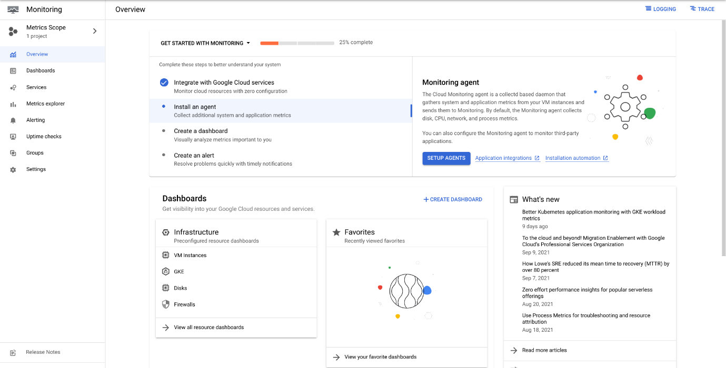

**Task 2. Custom dashboards**

Create a dashboard

* In the left pane, click **Dashboards**.
* Click **+Create Dashboard**.
* For **New Dashboard Name**, type **My Dashboard**.

**Add a chart**

* From **Chart library**, Select **Line**.
* For **Title**, give your chart a name (you can revise this before you save based on the selections you make).
* Type **CPU utilization** or **CPU usage** in Resource & Metric field, Click **VM Instance > Instance**. Select CPU utilization or CPU usage and click **Apply**.
* Click **+ Add Filter** and explore the various options.

Metrics Explorer

The **Metrics Explorer** allows you to examine resources and metrics without having to create a chart on a dashboard. Try to recreate the chart you just created using the **Metrics Explorer**.

* In the left pane, click **Metrics explorer**.
* For **Resource & Metric**, Select a Metric.
* Explore the various options and try to recreate the chart you created earlier.

**Note:**Not all metrics are currently available on the Metrics Explorer, so you might not be able to find the exact metric you used on the previous step.

**Task 3. Alerting policies**

Create an alert and add the first condition

* In the Cloud Console, from the **Navigation menu**, select **Monitoring > Alerting**.
* Click **+ Create Policy**.
* Click on **Select a metric** dropdown. Disable the **Show only active resources & metrics**.
* Type **VM Instance** in filter by resource and metric name and click on **VM Instance > Instance**. Select **CPU usage or CPU Utilization** and click **Apply**.

**Note:**If you cannot locate the **VM Instance** resource type, you might have to refresh the page.

* Set **Rolling windows** to 1 min.
* Click **Next**. Set Threshold position to **Above Threshold** and set **20** as your **Threshold value**.

Add a second condition

* Click **+ADD ALERT CONDITION**.
* Repeat the steps above to specify the second condition for this policy. For example, repeat the condition for a different instance. Click **Next**.
* In **Multi-condition-triggers**, for **Trigger when**, click **All conditions are met**.
* Click **Next**.

Configure notifications and finish the alerting policy

Click on the dropdown arrow next to **Notification Channels**, then click on **Manage Notification Channels**.

A **Notification channels** page will open in a new tab.

* Scroll down the page and click on **ADD NEW** for **Email**.
* Enter your personal email in the **Email Address** field and a **Display name**.
* Click **Save**.
* Go back to the previous **Create alerting policy** tab.
* Click on **Notification Channels** again, then click on the **Refresh icon** to get the display name you mentioned in the previous step. Click **Notification Channels** again if needed.
* Now, select your **Display name** and click **OK**.
* Enter a name of your choice in the **Alert name** field.
* Click **Next**.
* Review the alert and click **Create Policy**.

**Task 4. Resource groups**

* In the left pane, click **Groups**.
* Click **+ Create Group**.
* Enter a name for the group. For example: **VM instances**
* In the **Criteria** section, type **nginx** in the value field below **Contains**.
* Click **DONE**.
* Click **CREATE**.
* Review the dashboard Cloud Monitoring created for your group.

**Task 5. Uptime monitoring**

* In the Monitoring tab, click on **Uptime Checks**.
* Click **+ Create Uptime Check**.
* Specify the following, and leave the remaining settings as their defaults:

|  |  |
| --- | --- |
| **Property** | **Value (type value or select option as specified)** |
| **Title** | *Enter a title* then click Next |
| **Protocol** | **HTTP** |
| **Resource Type** | **Instance** |
| **Applies To** | **Group** |
| **Group** | *Select your group* |
| **Check Frequency** | **1 minute** |

* Click on **Next** to leave the other details to default. Under **Alert & Notification**, select your Notification Channels from the dropdown.
* Click **Test** to verify that your uptime check can connect to the resource.
* When you see a green check mark everything can connect. Click **Create**.

The uptime check you configured takes a while for it to become active.

**Task 6. Disable the alert**

Disable the alert Alerting policies stay active for a while after a project is deleted, just in case it needs to be reinstalled. Since this is a lab, and you will not have access to this project again, remove the alerting policy you created.

* Navigate to the **Alerting** section.
* From your **alert's Policy** details page, click the **Enabled** link at the top of the page.
* You will be asked to confirm that you want to disable the alerting policy - click **Disable**.

The link will now say Disabled.

**Task 7. Review**

In this lab, you learned how to:

* Monitor your projects
* Create a Cloud Monitoring workspace
* Create alerts with multiple conditions
* Add charts to dashboards
* Create resource groups
* Create uptime checks for your services